**Advanced Graphics Programming** Project 1 (Ray Tracing) - April 2020

| * The submission deadline is **April 11th at 23:59:59**. * Use **ShaderToy** to implement your raycasting code. * To deliver the exercise, just **upload the link** to your ShaderToy shader to the CITM virtual campus: **Project 1 - Ray Tracing** folder. * Make sure your shader is in unlisted mode (modo oculto). Please **do not make your shader public** as we are making use of this tool for a class exercise. |
| --- |

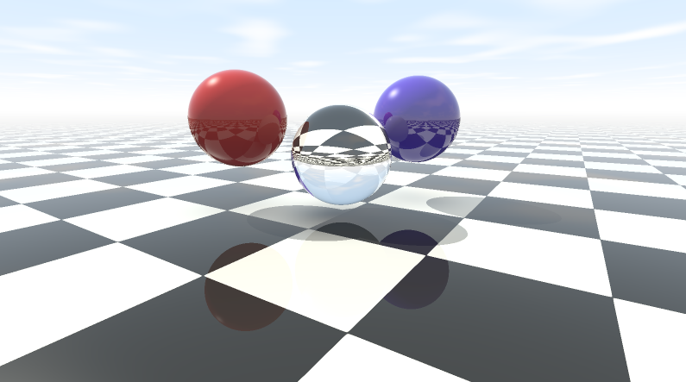

## Statement

Implement a 3D ray tracer as explained in class. Only spheres and planes are required for this assignment, but more complex shapes are welcome. For instance, a height map could define a bumpy floor (of course, in this case, the intersection could not be analytically computed, but a search over the ray should be executed; feel free to ask if you feel motivated).

## Features

The raycaster needs to have several features amongst the following:

* Selection of the nearest intersected object
* Camera movement / mouse interaction
* Local illumination (ambient, diffuse, specular)
* Hard shadows
* Reflections
* Refraction
* Distance fog
* Cloudy sky
* Floor / sphere textures (checkerboard, marble, wood, etc)
* Antialiasing